Pemphigus Vulgaris
A Case Report and review of literature

Dr. Sabah Nuri Mizel
BDS. Fellowship of Kurdistan Board for Medical Specialties (FKBMS)
Oral and Maxillofacial Medicine
Head of Oral Medicine Department in Nana Kali Hospital for Hematology and Oncology

Abstract
Pemphigus is a group of autoimmune, potentially life-threatening diseases that cause bullae that soon burst to from severe erosions affecting both the skin and mucous membrane. The oral mucous membrane is involved in a high proportion of the patients, in most of the cases the first signs of the disease appear in the oral mucosa. There are four main subtypes of pemphigus, of which, Pemphigus Vulgaris is the most common variety and accounts for more than 70 % of all the cases. Here, I shall present a case of lady who had finally got the wright diagnosis for her severe oral erosive ulcerative lesions which was Pemphigus vulgaris, after seeking medical help for the last six months from many internists doctors diagnosed her as having Behcet disease and received the treatment for Behcet disease for six months without any improvement. Then, finally improved after getting the correct diagnosis and treatment protocol by an oral maxillofacial medicine dentist specialist⁽¹⁾.
Keywords: Pemphigus vulgaris, erosive, bullae, oral medicine.

Introduction
Pemphigus is a group of immune bullous disorders affecting both the skin and mucous membrane with four main types of which, Pemphigus vulgaris is the most common . Characterized by the development of auto antibodies directed to antigens located at the hemi desmosomes which connects between the keratinocyte cells leading to intra epithelial bullae formation and loss of the adhesion between the keratinocyte cells. The intra epithelial bullae formed soon shall burst leading to erosive ulcers both at the skin and at the mucous membrane. This disease affects middle aged patients with high predilection of affecting the oral mucous membrane and in most of the patients affected with pemphigus, the oral mucous membrane is mostly affected and, hence, the oral maxillofacial dentists have a high role in early diagnosis and treatment of the disease, hence, saving life of the patient⁽¹⁾.

Case Report
A 63 years old lady presented with six months history of severe oral erosive ulcerative lesions associated with skin erosions.
History of Present illness: The patient started feeling bullae formation, some of them filled with clear fluids, others filled with blood, both at the skin and intra orally, those bullae soon rupture at the same day within a variable period of time ranging from 4- 8 hours, leading to both extra oral and intra oral erosive ulcers. She seeked help of many internists doctors who had diagnosed her with Behcet disease, received the treatment prescribed by them for Behcet disease, however, no any benefit and the condition became worse that she could not eat solid neither soft type of food, only fluids which made her loose 10 kgs of her body weight.
Past Medical History:
1-Brain Stroke for one year 2-Hpertensive on Rompirin E 100 mg. once daily.
Social History: Heavy smoker patient for 20 years duration. She is having stressful life events due to her son being in prison for more than one year till now.
Clinical examination: The extra oral examination showed bilateral both submandibular and sublingual tender lymph nodes associated with where very itchy and painful erosive skin ulcers located at the chest, scalp, upper arm, and trunk.
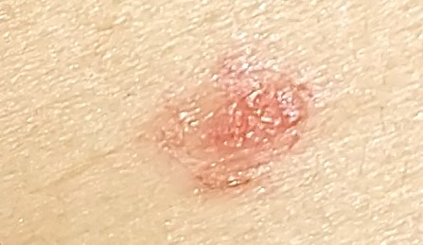
The intra oral examination: Generalized very painful erosive ulcerative lesions affecting almost the entire oral mucosal lining reaching the soft palate and Oro- pharynx posteriorly, and anteriorly reaching the vermilion borders of upper and lower lips with crustations. The tongue was also affected with white, easily, but painful swiped-off coating at the dorsal surface of the tongue.
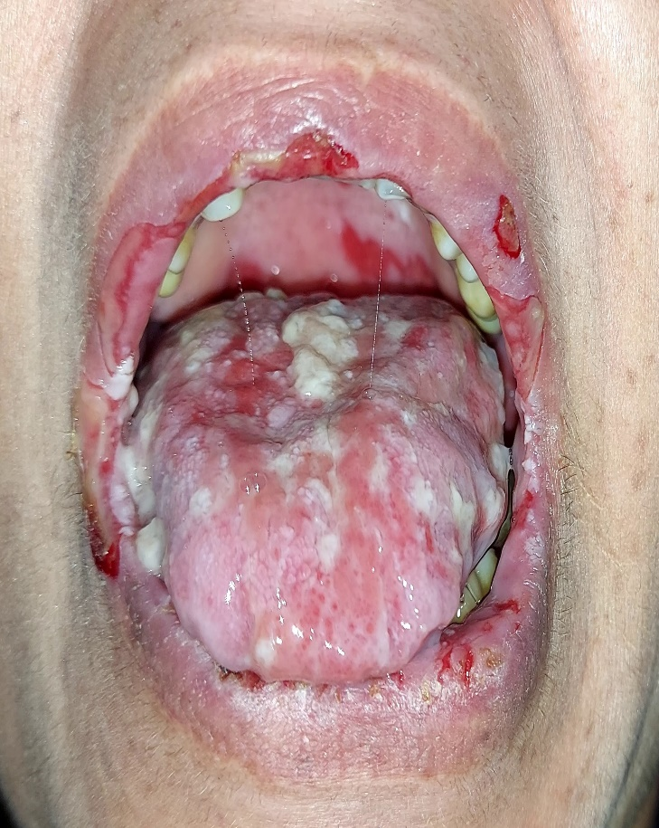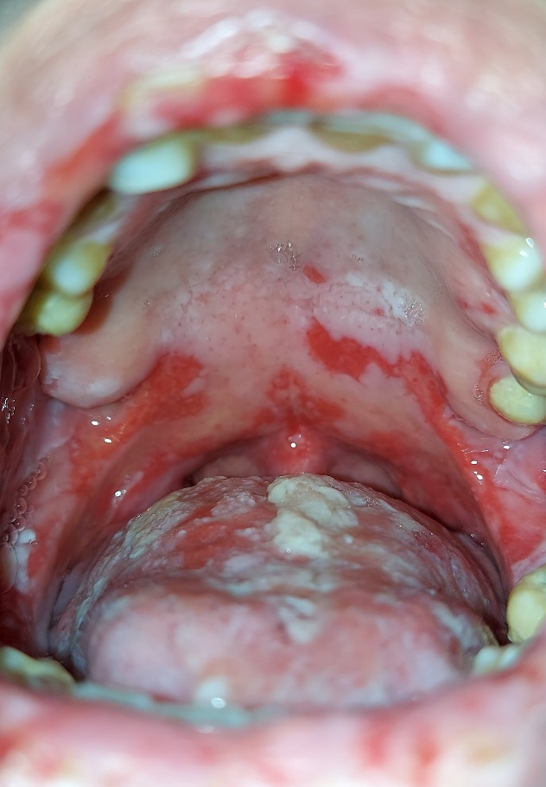
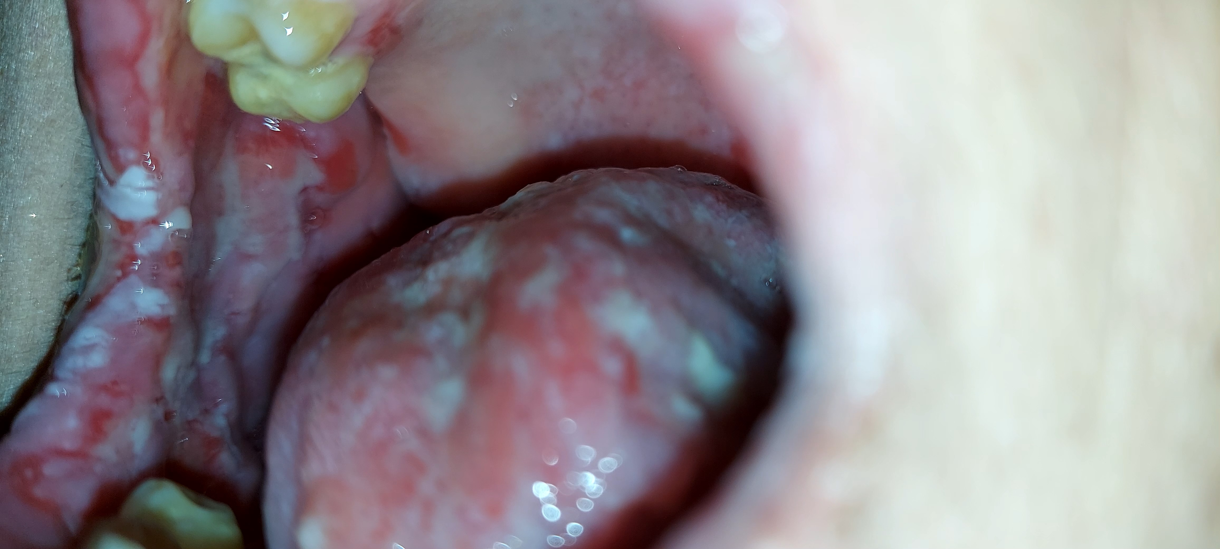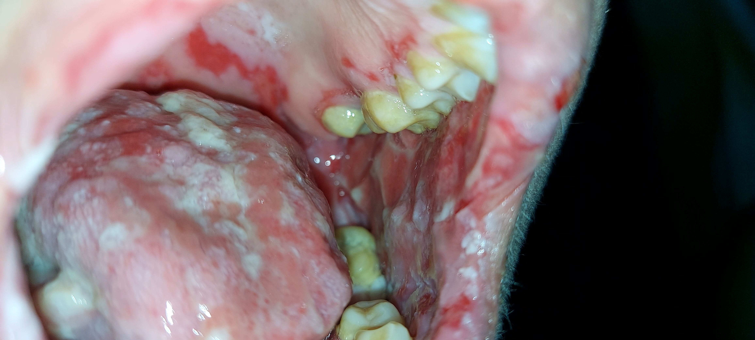

Investigations: Intra oral incisional biopsy for either direct immune fluorescent technique or for even the traditional histopathological examination was impossible due to the severe lacerations present. The diagnosis was made clinically through the presence of positive Nikolsky’s sign, which is characteristic of pemphigus vulgaris, in which a blister can appear on the normal-appearing skin if exerting lateral pressure and is very rare in the mucosa and other vesiculobullous diseases. shared feature between many vesiculo- bullous diseases like toxic epidermal necrolysis, and staphylococcal scalded skin syndrome (SSSS). This sign basically differentiates intraepidermal blisters from subepidermal blisters.
Management
The weight of the patient was 70 kg. so she was given
-Prednisolon tablets 20 mg. 1x4 ,
_Immuran 50 mg. 1x2
_Topical Tetracycline / triamcinolone mouth wash 1x3
_Topical nystatin oral drops 500 000 I.U.
_Topical fucidic acid cream H on the lips 1x3
_Topical Dermovet skin cream 1x3
Multidisplinar team approach with Internist regarding controlling her blood pressure, also with an endocrinologist for controlling her blood sugar
Follow up had been made . On re calling the patient after one week she presented with healing phase of the oral erosive ulcerative lesions and started oral intake, and healed skin denuded ulcers.
