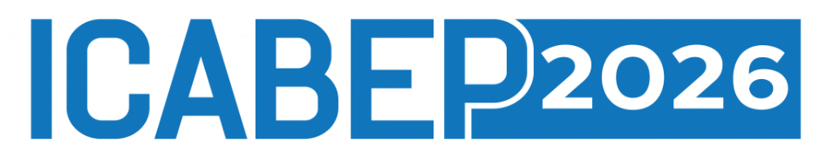
DETAILED CONFERENCE PROGRAMME
The 8th International Conference on Accounting, Business, Economics and Politics
25–27 May 2026 • University of Szczecin
Institute of Management • University of Szczecin • ul. Cukrowa 8, Room 010

PRE-CONFERENCE • MONDAY 25 May 2026

19:00 | WELCOME DINNER  Welcome Dinner  Restaurant: Ricoria Pomorzany Place • ul. Powst. Wlkp. 20, Szczecin

DAY ONE • TUESDAY26 May 2026

08:30 – 09:00 | REGISTRATION  Accreditation – Registration of Participants
09:00 – 09:15 | OPENING  Opening of the Conference & Welcome  National anthems: Poland, Kurdistan, Iraq  Presentation films of co-organising universities
09:15 – 10:00 | INAUGURAL  Inaugural Addresses  Representatives of Iraq and Erbil • Representative of Turkey  Rector of the University of Szczecin • Strategic Partner: ENEA  Dr. Gül Nazik Ünver – Cyberpolitik Journal and Association for Human Rights Education
10:00 – 10:15 | KEYNOTE  Keynote Lecture  Prof. Eleftherios Thalassinos — University of Piraeus, Greece
10:15 – 10:30 | KEYNOTE  Keynote Lecture  Prof. Tadeusz Trzaskalik — University of Economics in Katowice, Poland
10:30 – 10:45 | KEYNOTE  Keynote Speaker  Prof. Krzysztof Kompa - IPPM College of Business and Economics at the University of Johannesburg, South Africa  “From the economic development to the living standards  in sub-Saharan countries”
10:45 – 11:15 | BREAK  Coffee Break
11:15 – 12:00 | PANEL DISCUSSION  AI, Energy & Leadership: How AI is Reshaping Energy Management  Moderator: Wojciech Drożdż, Assoc. Prof., University of Szczecin  PANELLISTS & PRESENTATIONS  Prof. Paweł Szcześniak  University of Zielona Góra  Prof. Marcin Hołub  West Pomeranian University of Technology in Szczecin  Jakub Dowejko, PhD  University of Szczecin  Krzysztof Hajdrowski, PhD  ENEA S.A. — Conference Strategic Partner
12:00 – 12:15 | KEYNOTE  Keynote Speaker  Prof. Thomas Burkhardt — University of Koblenz and Landau
12:15 – 12:30 | KEYNOTE  Keynote Speaker  Prof. Vigita Vėbraitė  Dean of the Faculty of Law, Vilnius University, Lithuania  “Can AI Facilitate Conciliation in Civil Disputes?”
12:30 – 13:45 | PANEL DISCUSSION  Digitalisation and Artificial Intelligence in Decision-Making Proceedings in the System of Justice  Moderator: Kinga Flaga-Gieruszyńska, Assoc. Prof., University of Szczecin  PANELLISTS & PRESENTATIONS  Prof. Kinga Flaga-Gieruszyńska, Michał Wojdała, PhD  Faculty of Law and Administration, University of Szczecin  “The Digitalisation of the Administration of Justice in Civil Matters and the Right to a Fair Trial”  Prof. Joanna Studzińska,  Kozminski University, Warsaw  “New Technologies in the Work of Legal Counsel in Civil Proceedings”  Prof. Jurgis Bartkus  Advisor to the Dean on International Relations, Faculty of Law, Vilnius University  “AI v. Arbitrator: Can AI Improve Decision-Making in Arbitration Proceedings?”  Maria Dymitruk, PhD  Faculty of Law, Administration and Economics, University of Wrocław  “Artificial Intelligence in the Decision-Making Proceeding of a Civil Court Judge”  Prof. Izabella Gil, & Emilia Gil  Faculty of Law, Administration and Economics, University of Wrocław  “The Application of Artificial Intelligence in Determining the Grounds for Declaring a Debtor's Bankruptcy”  Prof. Neringa Gaubienė & Prof. Kristina Pranevičienė  Faculty of Law, Vilnius University, Lithuania  “The Importance of AI Literacy to Foster Responsible Use of Artificial Intelligence in Courts”  Aleksandra Klich, PhD & Att. Bartosz Skrendo  Faculty of Law and Administration, University of Szczecin / MCM Legal Law Office  “The Use of New Technologies in Expert Opinions in Civil Proceedings”
13:45 – 14:30 | LUNCH  Lunch Break
14:30 – 14:45 | KEYNOTE  Keynote Speaker  Witold Repetowicz, PhD — War Studies University
14:45 – 15:45 | PANEL DISCUSSION  European Security in Transition: Energy, Nuclear Policy, and Institutional Limits in the Shadow of the War in Ukraine  Moderator: Prof. Tomasz Czapiewski, University of Szczecin  PANELLISTS & PRESENTATIONS  Łukasz Jureńczyk  Kazimierz Wielki University in Bydgoszcz  “Polish Atom — Should Poland Limit Itself to a Civilian Nuclear Programme?”  Ewelina Kochanek & Michał Romańczuk  University of Szczecin  “Geopolitical Determinants of Energy Security in the Current Decade of the 21st Century”  Grzegorz Ciechanowski  University of Szczecin  “Geopolitical Security Determinants for Central and Eastern Europe in the Context of the War in Ukraine”  Julia Kołodziejska  University of Szczecin  “The OSCE and Its Limitations in Contemporary Conflicts”  Wojciech Wilczko  Territorial Defence Force  “The Role of the Multinational Corps Northeast Command in Defending NATO's Eastern Flank”
15:45 – 16:00 | KEYNOTE  Keynote Lecture  Prof. Simon Grima — University of Malta
16:00 – 16:05 | CLOSING  Closing Remarks — Day One
19:00 | GALA DINNER  Gala Dinner  Ricoria Pomorzany Place • ul. Powst. Wlkp. 20, Szczecin

DAY TWO • WEDNESDAY 27 May 2026

10:00 – 10:15 | KEYNOTE  Keynote Speaker  Prof. Gratiela Georgiana Noja — West University of Timișoara
10:15 – 10:30 | KEYNOTE  Keynote Speaker  Prof. Dorota Maria Witkowska - IPPM College of Business and Economics at the University of Johannesburg
10:30 – 10:45 | KEYNOTE  Keynote Speaker  Prof. Salah Koubaa — Hassan II University of Casablanca
10:45 – 11:00 | KEYNOTE  Keynote Speaker  dr Dominik Rozkrut – University of Szczecin
11:00 – 11:45 | SCIENTIFIC SESSION  Sustainable Economic Transformation: Markets, Governance, and Inclusion  Moderator: TBA  PRESENTATIONS  Aleksandra Matuszewska-Janica  Dept. of Econometrics and Statistics, Inst. of Economics and Finance, Warsaw University of Life Sciences (SGGW), Poland  “Women and the Labour Market in the European Union: A Sustainable Development Perspective”  Katarzyna Czech & Michał Wielechowski  Dept. of Econometrics and Statistics / Dept. of Economics and Economic Policy, Inst. of Economics and Finance, Warsaw University of Life Sciences (SGGW), Poland  “Geopolitical Shocks and Regime-Dependent Oil Price Volatility: Evidence from Middle East Escalations in 2025–2026”  Ninditya Nareswari  Doctoral School, University of Szczecin, Poland  “Exploring the Effects of Economic Growth, Renewable Energy, Human Capital, and Environmental Technology on CO₂ Emissions in Heterogeneous Emerging Economies”  Bahalwan Apriyansyah  Doctoral School, University of Szczecin, Poland  “A Pilot Investigation of Consumer Culture Positioning Strategies in Indonesian and Polish Advertising Markets”
11:45 – 12:00 | BREAK  Coffee Break
12:00 – 12:45 | PANEL DISCUSSION  Managing Urban Mobility Services in Relation to the Needs of an Ageing Society  Moderator: Zuzanna Kłos-Adamkiewicz, PhD, University of Szczecin  PhD Agnieszka Gozdek – University of Szczecin  Michał Babicki – Wolański Sp. z o.o.
12:45 – 13:45 | PARALLER SCIENTIFIC SESSION ROOM 002  Scientific Session — Tishk International University  Moderator: TBA  PRESENTATIONS  Dana Mohammed Danish Aladdin Sajadi  Tishk International University  “From Liberal Hegemony to Strategic Disorder: Trump's Foreign Policy and the Reshaping of the International System”  Abubakar Balarabe Karaye  Tishk International University  “The Impact of Board Gender Diversity on Global Sustainability Performance: The Moderating Role of Government Effectiveness”  Abdullah Nabeel Jalal  Tishk International University  “Human–AI Collaboration Models in Enterprise Information Systems”  Nyaz Abdulla Abdulla  Tishk International University  “Entrepreneurship Development: New Business Start-ups, Challenges and Opportunities in the Kurdistan Region of Iraq”  Nurullah Darıcı  Tishk International University  “Roles of Language on Political and Administrative Issues”  Ahmet Demir  Tishk International University  “Fuzzy AHP and VIKOR to Select the Best Location for Bank Investment: A Case Study in the Kurdistan Region of Iraq”
12:45 – 13:45 | PARALLER SCIENTIFIC SESSION ROOM 010  Scientific Session  Moderator: Anna Borawska, PhD • Piotr Niemcewicz, PhD  PRESENTATIONS  Ibrahim Kurnaz  Cyberpolitik Journal and Association for Human Rights Education  Gül Nazik Ünver  Cyberpolitik Journal and Association for Human Rights Education  Maurycy Gawriłow  University of Szczecin, Poland  “Energy Security in Europe: Navigating Geopolitical Conflicts and Strategies for Future Resilience”  Maurycy Gawriłow  University of Szczecin, Poland  “Economic Viability of Energy Transition in Poland: Comparative Analysis of Coal-based vs. Renewable Energy Costs”  Patryk Wlekły & Maria Motyka  University of Szczecin, Poland  “Polish Legal Regulations on OTC Medicine Advertising and Their Impact on Patients' Market Behaviour”  Prof. Dr Ibish Mazreku & Prof. Dr. Halit Shabani  University “Haxhi Zeka’’, Faculty of Business, Department Risk Management and Insurance, Kosovo  “AI-Driven Risk Management and Sustainable Finance in Transition Economies: Opportunities and Challenges for Kosovo’s Financial Sector”
13:45 – 14:00 | CLOSING  Closing of the Conference

LEGEND
KEYNOTE | PANEL DISCUSSION | SCIENTIFIC SESSION | OPENING / CLOSING | DINNER / BREAK

ORGANISERS & PARTNERS

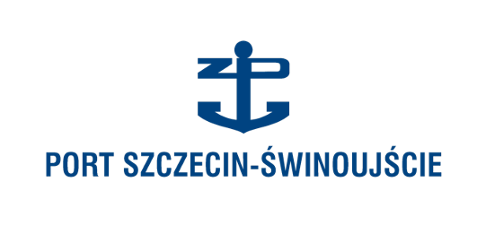


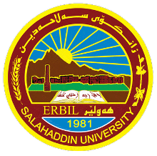


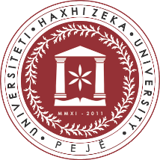
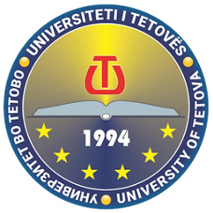


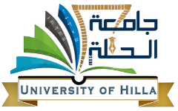


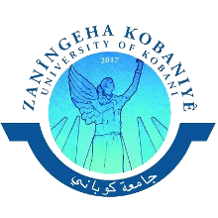
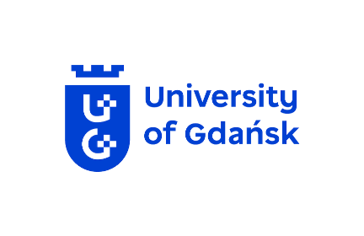
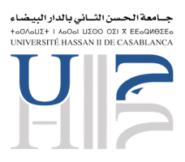
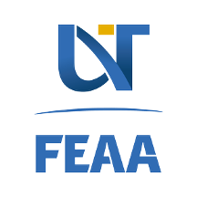
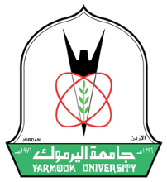

ICABEP 2026 • University of Szczecin • 25–27 May 2026

